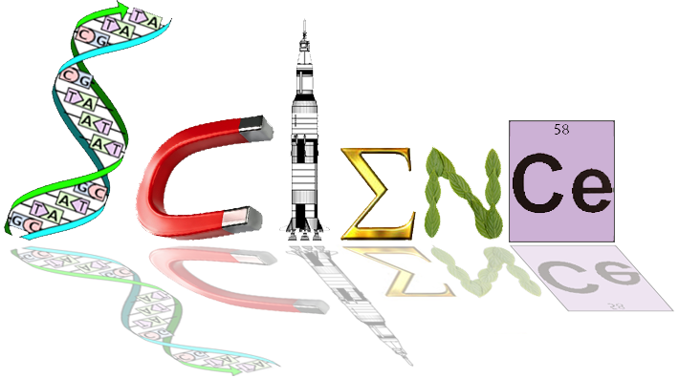


12 HB Human Biology
Unit 4 ATHBY
Task 11 – Mechanism & Evidence of Evolution Test /61 marks

Multi Choice Section (15 marks)

Question 1 refers to the following diagram of a phylogenetic tree:

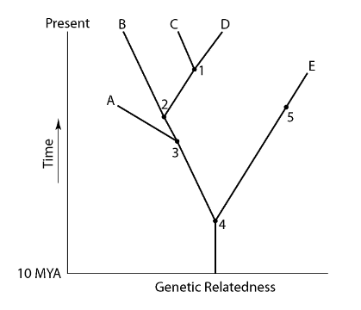

1. A common ancestor for both species C and E could be at position number

- 1
- 2
- 3
- 4

2. Fossilisation of soft tissues is least likely to occur in

- the presence of decay bacteria.
- sheltered conditions in a cave.
- volcanic ash when organisms are smothered.
- swamps under fine mud sediments.

3. Homologous organs:

- suggest that the species do not share a common ancestor.
- are a pair of chromosomes that contain genes that encode for the same structures.
- are organs that have a similar structure but may have different functions.
- are organs that have a similar structure and similar functions.

4. This question refers to the list of statements below.

- The fossil record has some specimens that show a gradual progression over an extended period of time to the present day.
- The fossil record shows that some species have undergone no changes over time.
- Protein analysis demonstrates that related species show much similarity in the sequence of their amino acids.
- Vertebrates display a similar arrangement of their upper limb bones.

Which of the above statements provide evidence to support the theory of evolution?

- (i) and (ii) only.
- (i), (iii), and (iv)
- (i) and (iv) only
- (i), (ii), (iii) and (iv)

Question 5 refers to the diagram below, which shows the sequences of rock strata from four locations.
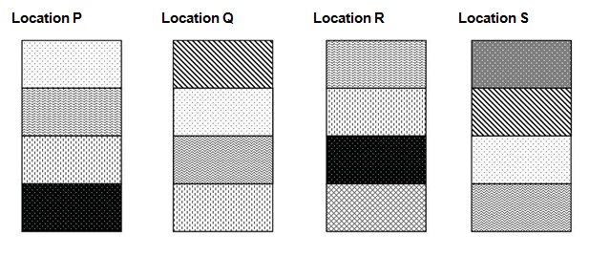
5. Which location appears to have the oldest stratum?

- P
- Q
- R
- S

6. All primates have:

- grasping hands, forward facing eyes and five digits.
- scent glands, stereoscopic vision and an enlarged cerebellum.
- ischial callosities, colour vision and a non-specialised body.
- tails, a reduced sense of smell and an enlarged cerebrum.

7. Australopithecine fossils have been found in:

- Africa.
- Africa and Asia.
- Africa and Southern Europe.
- Africa, Southern Europe and Asia.

8. Which of the following correctly lists the cultural advances of the hominin group in the most likely sequence of development (from earliest to most recent)?

  - painting, use of fire, manufacture of simple stone tools, agriculture
  - agriculture, painting, use of fire, manufacture of simple stone tools
  - manufacture of simple stone tools, use of fire, painting, agriculture
  - use of fire, painting, agriculture, manufacture of simple stone tools

9. Which of the following is NOT an adaptation to upright stance or bipedal locomotion?

- The foramen magnum is located towards the back of the skull.
- The heel bone is enlarged.
- Vertebrae in the lower part of the spine are wedge-shaped.
- The pelvis is broad and short.

10. Which of the following statements are true for Homo neanderthalensis?

- first hominins known to make use of fire
- first hominins known to construct shelters
- were efficient hunters of large animals
- used flake tools to make clothes
- manufactured portable art depicting fertility symbols

Which of the above statements are correct?

  - (i) and (iii) only
  - (i), (ii) and (iv) only
  - (iii), (iv) and (v) only
  - (iii) and (iv) only

11. The term ‘carrying angle’ refers to the

  - forward tilt of the body of most primates during bipedal or quadrupedal locomotion.
  - angle created between the long axis of the femur and the vertical.
  - orientation of the foramen magnum to the vertical axis of the skull of most primates.
  - forward tilt of the pelvis during bipedal locomotion.

Questions 12 and 13 refer to the lower jaw diagrams shown below.

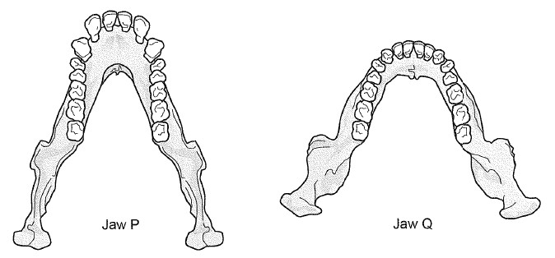

12. Which of the following statements about the lower jaws shown in the diagrams is correct?

  - Jaw P belongs to a modern human because the dental arcade has a parabolic shape.
  - Jaw Q belongs to a great ape because the teeth are of an even size.
  - Jaw P belongs to a great ape because of the presence of a diastema.
  - Jaw Q belongs to a modern human because there are more molars present than in Jaw P.

13. If the complete skeleton of the specimen belonging to Jaw Q was examined, which of the following characteristics would it be expected to have?

  - longitudinal and transverse arches of the foot
  - small outer condyle of the femur at the knee joint
  - only one curvature of the vertebral column
  - bowl shaped pelvis that is long from top to bottom

Questions 14 and 15 refer to the stone tools shown below.

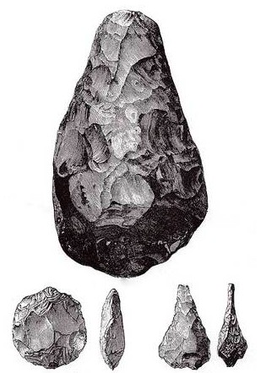

14. To which tool culture do the tools shown above belong?

  - Oldowan pebble tools
  - Acheulian hand axes
  - Aurignacian blade tools
  - Magdalenian barbed spears

15. What cultural advance would also be associated with the group of individuals responsible for making the stone tools shown above?

  - construction of murals and portable art
  - beginning of farming practices
  - evidence of rituals and burial of the dead
  - beginning to use fire – (because Homo erectus)

Short Answer (36 marks)

16. Explain how the study of comparative DNA can provide evidence for evolution. (2 marks)
- Even species that seem to be different actually have large sections of identical DNA
- How closely or distantly species are related is based on the amount of difference in DNA

17. Parts (a) and (b) of this question refer to the diagram below.

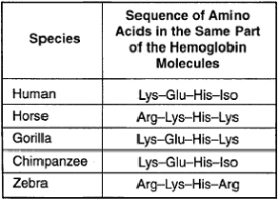

a) The specific type of study shown above is used to provide evidence for evolution. Name this type of study and describe how it provides evidence for evolution. (2 marks)

- Comparative studies in biochemistry/protein analysis
- The more similar the amino acid sequence in proteins of two species, the more likely they are to have diverged from a common ancestor

b) Explain how the study of ubiquitous proteins can provide evidence for evolution. (2 marks)
- Cytochrome c and haemoglobin are compared to determine the relationship between two species
- Cytochrome c is a small protein that plays an important role in the electron chain within mitochondria of all cells
- An analysis of cytochrome c shows the similarities and differences between species

c) Using the diagram above, explain the evolutionary relationship of the human to the horse compared with the human to the chimpanzee. (2 marks)

- Human & chimpanzee have identical amino acid sequence in their haemoglobin molecules
- Human & horse share one common amino acid in their haemoglobin molecules.
- Therefore human and chimpanzee are more closely related

18. Complete the table below, describing the evolutionary trends that occur within the family Hominidae. (3 marks)

Characteristic | Evolutionary trend
Mobility of digits of the hand | Pentadactyl: 5 digits on each limb  Digits can be moved independently of one another thus increased mobility
Prognathism | Apes have flattened nose but more pronounced prognathism  Whilst the rest of the face has flattened & less prognathism, the nose has not
Size of molar teeth | Molar becomes smaller  Lower molars have 5 cusps forming Y-5 pattern

19. As hominins evolved their cranial capacity gradually increased. For each of the three functional areas of the cerebral cortex listed below, explain one advantage an increased brain size gave to early Homo sapiens to enable them to survive in their environment. (3 marks)

Functional area of cerebral cortex | Advantage
Association | Higher order thinking better communication skills and language development  Also planning for hunting, seasonal produce etc.
Motor | Increase in the capacity for tool making
Sensory | Vision, expanded memory and processing data about the surroundings

20. Parts (a) and (b) of the question refer to the hominin skull diagrams A, B, C, and D shown below.
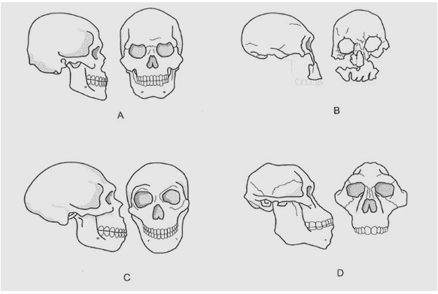

a) Place the skulls A, B, C and D in the correct evolutionary sequence, from oldest to most recent.
D, B, C, A (1 mark)
Should this be 1 mark or 4?

b) Describe the evolutionary trend that can be seen in hominin fossils associated with the jaw. Explain why this trend is believed to have occurred. (2 marks)

- Smaller teeth /reduced jaw muscle associated with a change in diet from herbivorous to omnivore
- Change from ‘U’ to parabola shaped jaw / reduced size in molars associated with moved towards cooked / softer food
- Chin – increased chin to allow for attachment of muscles used in speech

c) Describe the general trend in the evolution of hominin teeth and describe cultural factors that may have influenced this trend. (3 marks)
- Smaller teeth
- Loss of prominent canine and diastema
- use of fire to cook roots and tubers
- hunting for meat

d) What features of a fossilised skeleton would clearly indicate the individual was bipedal? (3 marks)
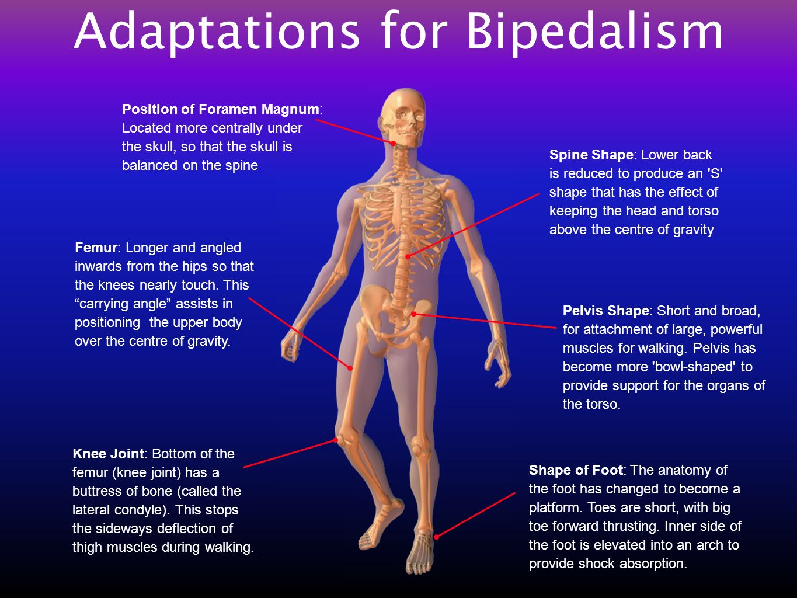

21. (a) Name the hominin that was the first to;

(i) use fire ___H. Erectus_
(ii) use ritual burial _______H.Neanderthalensis___
(iii) domesticate animals _____H. Sapien__________
(3 marks)

(b) Name the hominin that produced the art forms shown in this diagram.

____________Cro-magnon__or Homo sapien_____________________ (1 mark)

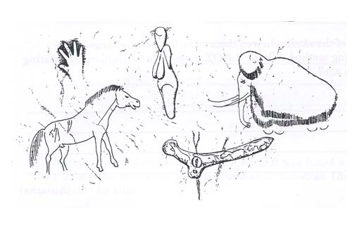
(c) For each of the following identify the tool culture and the associated hominin group.
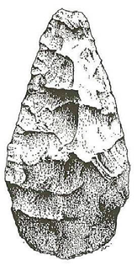
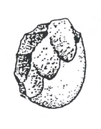

Tool culture____Acheulean______________ Tool culture__Oldowan
Hominin _____H.erectus Hominin ___Australopithecine or Homo habilis
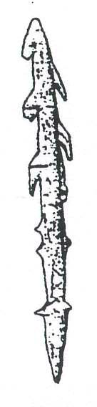
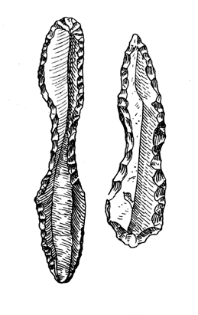

Tool culture___Mousterian_________ Tool culture___Magdalenian ______
Hominin __H. neanderthalensis_____ Hominin ___Cro-Magnon__or Homo sapien________
(4 marks)

22. The diagram below shows a phylogenetic tree of present-day hominids. The numbers in ovals at the branch points indicate the percent DNA similarity with humans.

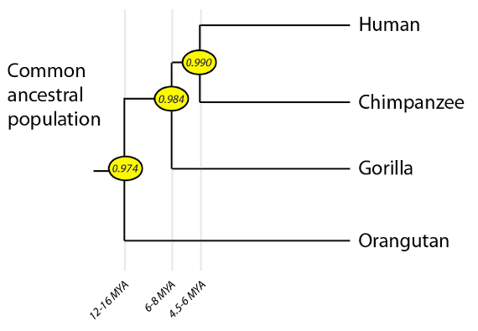

On the basis of the information contained in the phylogenetic tree, are Humans more closely related to Gorillas or Orangutans? Explain your answer. (2 marks)
More closely related to Gorilla
with 98.4% DNA similarity

Extended Answer - (10 Marks)

Archaeologists discovered an almost complete hominid specimen in Israel. The fossil was dated at approximately 60000 years old. Initially archaeologists did not know whether the specimen belonged to Homo neanderthalensis or modern homo sapiens. With more detailed inspection of the skeletal characteristics it was decided the specimen was Homo neanderthalensis.

- Describe the process that leads to the development of homo neanderthalensis. (7 marks)
One mark for key word (bold) and one mark for matching description. – just one mark for both?
Answer must make sense and be in order.

VARIATION – there is genetic variation within a species
Humans and Neanderthals shared a common ancestor that lived 800,000 years ago in Africa Many humans today share a small portion of Neanderthal DNA Neanderthals lived in small, isolated groups that had little contact with each other
ISOLATION – Organisms are geographically isolated from each other
Neanderthals ancestors originated from Africa then migrated to Europe and part of Asia Neanderthal ancestor evolved into Homo neanderthalensis

COMPETITION – individuals compete for scarce resources
SURVIVE – those most able to use resources survive the most
Fossil evidence shows that Neanderthal prey, including woolly mammoths, may have shifted their range further south, leaving Neanderthals without their preferred foods.

REPRODUCE – those most able to survive produce the most offspring
Modern humans and Neanderthals interbred

MOST FIT – those that produce the most offspring are the most fit
Neanderthals were hunter-gatherers, living in harsh environments

SPECIATION – the genes of the most fit become most common, and differences accumulate over time that lead to a new species
Neanderthals gradually disappeared through interbreeding with humans. Over many generations of interbreeding, Neanderthals—and small amounts of their DNA—may have been absorbed into the human race.
b) Describe three features of the post – cranial skeleton (below the skull – not ‘posterior’ as on test, this confused the anatomy/PE students) that allowed them to distinguish it as
Homo neanderthalensis rather than homo sapiens. (3 marks)
Any three features as listed
